***Adventurous Game***

**Code:**

import time

import random

class Player:

def init(self, name):

self.name = name

self.health = 100

self.inventory = []

def display_stats(self):

print(f"\n{name}'s Health: {self.health}")

print("Inventory:", ', '.join(self.inventory))

def introduction():

print("Welcome to the Adventure Game!")

time.sleep(1)

print("You are a brave hero on a quest to rescue the kidnapped princess.")

time.sleep(1)

print("Your journey begins in the small village of Rivertown.")

time.sleep(1)

def make_choice(options):

print("\nChoose your action:")

for i, option in enumerate(options, 1):

print(f"{i}. {option}")

choice = int(input("Enter the number of your choice: "))

return choice

def explore_village(player):

print("\nYou start exploring the village of Rivertown.")

time.sleep(1)

print("You come across a market, a blacksmith, and an old tavern.")

choices = ["Visit the market", "Go to the blacksmith", "Enter the tavern"]

choice = make_choice(choices)

if choice == 1:

print("\nYou visit the market and buy some supplies.")

player.inventory.append("Health Potion")

elif choice == 2:

print("\nThe blacksmith gives you a sword to aid in your quest.")

player.inventory.append("Sword")

else:

print("\nIn the tavern, you hear rumors about the princess's location.")

time.sleep(1)

print("What do you do?")

choices = ["Listen to rumors", "Challenge someone to a duel"]

choice = make_choice(choices)

if choice == 1:

print("\nThe rumors hint at a dark cave to the north.")

return True

else:

print("\nA brawl ensues, and you lose some health.")

player.health -= 10

return False

def enter_cave(player):

print("\nYou decide to follow the rumors and head towards the dark cave.")

time.sleep(1)

print("Inside the cave, you encounter a fork in the path.")

choices = ["Take the left path", "Take the right path"]

choice = make_choice(choices)

if choice == 1:

print("\nYou take the left path and encounter a group of bandits.")

time.sleep(1)

print("What do you do?")

choices = ["Fight the bandits", "Try to sneak past them"]

choice = make_choice(choices)

if choice == 1:

print("\nYou engage in a fierce battle with the bandits.")

if "Sword" in player.inventory:

print("Having a sword, you manage to defeat them.")

else:

print("Without a proper weapon, the bandits overpower you.")

player.health -= 30

else:

print("\nYou attempt to sneak past the bandits.")

success = random.choice([True, False])

if success:

print("You successfully sneak past them.")

else:

print("The bandits spot you and demand a toll.")

player.inventory.append("Gold Coin")

else:

print("\nYou take the right path and encounter a mystical creature.")

time.sleep(1)

print("What do you do?")

choices = ["Attempt to communicate", "Attack"]

choice = make_choice(choices)

if choice == 1:

print("\nThe creature seems friendly and guides you deeper into the cave.")

else:

print("\nThe creature retaliates, and you lose some health.")

player.health -= 20

return player.health > 0

def rescue_princess(player):

print("\nAs you venture deeper into the cave, you discover the kidnapped princess!")

time.sleep(1)

print("Congratulations! You have successfully rescued the princess.")

def main():

introduction()

player_name = input("Enter your hero's name: ")

player = Player(player_name)

if explore_village(player):

if enter_cave(player):

rescue_princess(player)

print("You have completed your quest and saved the day!")

else:

print("\nYour journey ends in defeat.")

else:

print("\nYour adventure in Rivertown concludes.")

if name == "main":

main()

**Output:**

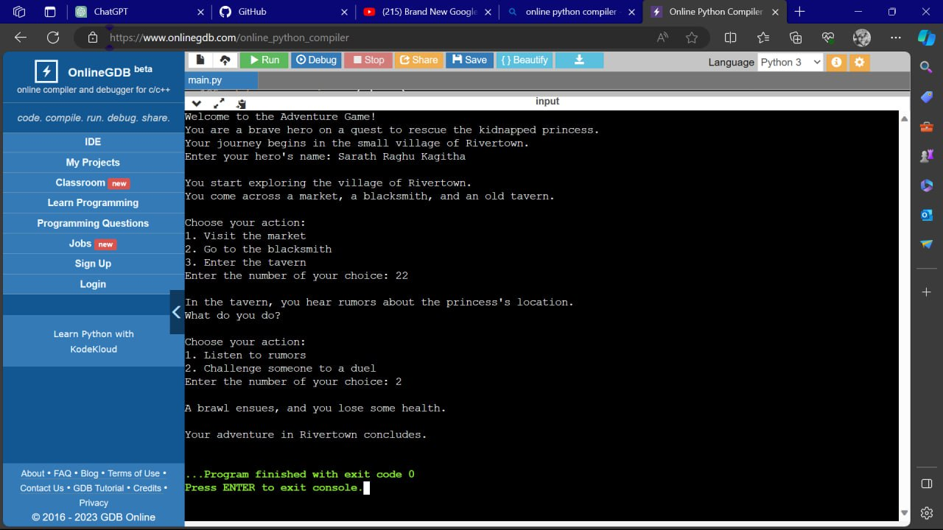



**The End**